**GENETIC DIVERSITY OF COWPEA (vigna Unguiculata L. Walp) WITH DARK BROWN AND MULTED RED SEED COAT COLOUR BASED ON COOKING TIME**

**BY**

**ADUKWU, PERPETUAL OJ**

**U2016/5545172**

**DEPARTMENT OF PLANT SCIENCE AND BIO TECHNOLOGY**

**FACULTY OF SCIENCE**

**UNIVERSITY OF PORT HARCOURT**

**February, 2023**.

**GENETIC DIVERSITY OF COWPEA (vigna Unguiculata L. Walp) WITH DARK BROWN AND MULTED RED SEED COAT COLOUR BASED ON COOKING TIME**

**BY**

**ADUKWU, PERPETUAL**

**U2016/5545172**

**DEPARTMENT OF PLANT SCIENCE AND BIO TECHNOLOGY**

**FACULTY OF SCIENCE**

**UNIVERSITY OF PORT HARCOURT**

**A RESEARCH PROJECT SUBMITTED TO THE DEPARTMENT OF PLANT SCIENCE AND BIOTECHNOLOGY, FACULTY OF SCIENCE, UNIVERSITY OF PORT HARCOURT, RIVERS STATE, NIGERIA.**

**IN PARTIAL FULFILLMENT OF THE REQUIREMENT FOR THE AWARD OF BACHELOR OF SCIENCE (BSc. HONS) DEGREE IN PLANT SCIENCE AND BIOTECHNOLOGY.**

**February, 2023**.

**DECLARATION**

I, ADUKWU, PERPETUAL U2016/5545172, with the matriculation number U2016/5545172 hereby declare that this project work on genetic diversity of cowpea (vigna unguiculata l. walp) with dark brown and multed red seed coat colour based on cooking time was carried out by me, and this is y original work and has not been submitted wholly or in part for award in any institution.

............................ ............................

**DR. B.A ODOGWU ADUKWU, PERPETUAL**

(Project Supervisor) (Student)

**CERTIFICATION**

This is to certify that this project design was carried out by Adukwu, Perpetual (U2016/5545172), under the supervision of Dr. Blessing A. Odugwu and approved by the under signed persons in fulfilment of the requirement for the award of Degree of Bachelor of Science in the Department of Plant Science and Biotechnology, Faculty of Science, University of Port Harcourt.

**DR ODOGWU BLESSING**  ……………… ……………

(Supervisor) Signature Date

**PROF. I.O, AGBAGWA** …………… …………..

Head of Department Signature Date

**PROF. E. B ESSIEN**  …………. ………......

(Dean Faculty of Science) Signature Date

**EXTERNAL SUPERVISOR** ……………. ……..........

Signature Date

**DEDICATION**

This work is dedicated to GOD Almighty for his kindness, goodness, and mercy through this period of my undergraduate academic work.

**ACKNOWLEDGEMENT**

My profound gratitude goes to God Almighty, for his grace and strength throughout this project research.

My appreciation also goes to my guidance, Adukwu Gloria and Mr Stephen David for their immersed support.

I also appreciate the effort of my supervisor, Dr Odogwu Blessing, who made this project a success and my honourable Head of Department, Prof. I. O Agbawa and all my Professors, lecturers and the entire staff of the Department of Plant Science and Biotechnology. May God continue to bless you all.

My sincere appreciation goes to my friends, Chioma Grant, Ezekiel Prosper, Clinton Daniel, and Faithful for their encouragement. I also want to thank my project colleagues Peculiar, Fega, Woshi for their support. Thank you all.

TABLE OF CONTENTS

CHAPTER ONE: INTRODUCTION/ LITERATURE REVIEW

INTRODUCTION 3

1.2 Aim and Objectives 4

1.2.1 Aim 4

1.2.2 Objectives 4

1.3 Significance of the Study 4

1.4 Literature Review 4

1.4.1 Origin and Distribution 4

1.4.2 Morphology 5

1.4.3 Growth Habit 6

1.4.4 Economic Value 7

1.4.5 Pest and Diseases 9

CHAPTER 2: MATERIALS AND METHODS

2.1 Sources of Plant Materials 11

2.2 Methods 11

2.2.1 Cooking Methodology 11

2.2.2 Soaking: 11

2.2.3 Cooking Evaluation 12

CHAPTER THREE 15

Results 15

3.2 Genetic Diversity of the Cowpea Seeds 15

3.2.1 Cluster analysis 15

3.2.2 Correlation of the cooking and textural characteristics 17

3.1 Cooking Evaluation 19

CHAPTER FOUR: DISCUSSION, CONCLUSION AND RECOMMENDATION

4.1 Discussion 22

4.2 Conclusion 23

4.3 Recommendation 23

REFRENCES 24

**LIST OF TABLES**

Table 3.1: The textural characteristics of the 30 cowpea seeds used in this study

**LIST OF FIGURES**

Figure 3.1: Cluster analysis based on the cooking time and textual characteristics

Figure 3.2: Chart showing the cooking time of various accessions.

Fig. 3.3: Heat-map based on the cooking time and textual characteristics of the 30 cowpea seeds used in this study

**LIST OF PLATES**

Plate1.1: morphology of Cowpea

Plate 2.1: Soaked Cowpea Samples

Plate 2.1: Cooking Process.

Plate 3.1: Showing the broth water

Plate 3.2: Checking for the Broth opacity using the Refractor (ATAgo pocket PAL -1)

**ABSTRACT**

Cowpea grains (*VignaUnguiculata*(L.) Walp is an herbaceous legume. Cowpeas are grown mostly for their edible dried kidney shaped seeds. The cooking time quantities were carried out across 30 accessions from the Institute of Agricultural Research (IAR) Samaru, Zaria in the Northern part of Nigeria. The research was conducted at the Regional Centre for Biotechnology and Bio Resources Research of the University of Port Harcourt, Rivers state Nigeria. The research was carried out by using one stage Laboratory screening for the Phenotypic Assessment of Cooking Characteristics. Results shows that the accessions 255 TVU- 12353, 136 lAR-016-052 and 36 lAR-016-047 have the shortest time for cooking at 120 minutes and therefore recommended as promising parents in breeding for shorter cooking time.

**CHAPTER ONE**

**INTRODUCTION/ LITERATURE REVIEW**

* 1. **INTRODUCTION**

Cowpea (*Vignaunguiculata*) is an [annual](https://en.wikipedia.org/wiki/Annual_plant) [herbaceous](https://en.wikipedia.org/wiki/Herbaceous_plant) [legume](https://en.wikipedia.org/wiki/Legume) from the genus [*Vigna*](https://en.wikipedia.org/wiki/Vigna).Common names for cultivated cowpeas include; black-eye pea, southern pea, niebe(alternatively ñebbe), andcrowder pea.Cowpea is a diploid, having 2n=2x=22, with the size of its genome consisting of approximately 620 million base pairs (Lonardi*et al.,* 2019).Having originated in Africa, cowpea is now grown worldwide in 100 countries (Gonçalves*et al.,* 2016). The cowpea yield in 2020 was estimated to be in the region of 9.8 million, while by 2030, the projected yield is expected to rise to 12.3millon tons (Boukar*et al.,* 2016).

Cowpeas are grown mostly for their edible dried kidney shaped seeds, although the leaves, green seeds and pods can also be consumed. It is believed to be the most widely grown, distributed, and traded leguminous food commodity within Nigeria as reported by (Ejiga., 2003), and it is the most widely consumed legume in Nigeria primarily because of its taste and the ease in which it is prepared and incorporated into other recipes (Onigbinde*et al.,* 2003).These beans serve as the largest single contributor to the total protein intake of many rural and urban families (Dolvo*et al.,* 2006).Beans have long been recognized as a valuable source of plant protein, vitamins (thiamine and niacin), minerals (P, K, Ca, Mg), and dietary fiber. There is considerable evidence that foods high in water-soluble dietary fiber, such as oats or bean products and purified forms of water-soluble dietary fiber, can reduce blood cholesterol (Johnston *et al.,* 2003).

Legumes contain twice as much protein as cereals and except for the sulphur containing amino acids (methionine and cystine which are adequate in cereals) the amino acid profile of most legumes complements those of cereals (Fashakin, andOjo,2008).The ever-escalating prices of animal protein sources and insufficient local production, has led to an increased demand for cheap and good quality protein foods such as cowpea (Akinyele*et al.,* 2008).Different studies have been carried out on the cooking time,but there is limited information as regards to the cowpea with the best cooking time. This research tends to breach that gap.

**1.2 AIM AND OBJECTIVES**

**1.2.1 AIM**

The main aim of this research is to study 30 accessions of leguminous cowpea for cooking and textural characteristics.

**1.2.2 OBJECTIVES**

To compare the different varieties of the leguminous plant “Cowpea” and to observe their cooking time and their agronomy.

* 1. **SIGNIFICANCE OF THE STUDY**

This study is significant in helping to determine the cooking time of the 30 accession to ascertain the one with a shorter cooking time.

1.4 **LITERATURE REVIEW**

**1.4.1 ORIGIN AND DISTRIBUTION**

Cowpea as reported by (Singh *et al.,* 2014) originated in West African Farming and today, it is widely grown in West Africa.The main cowpea-producing countries of the world are in sub-Saharan Africa that is the Sudano-Sahelian vegetation region (Boukar*et al.,* 2019). In the cowpeas, top dry production,Nigeria has the highest production of 3,647,115, followed by Niger 2,637,486,Burkina Faso666,023, Kenya 264,160 and Senegal 253,897in terms of the metric ton production levels of cowpea grain.

**The Botanical Taxonomy of *Vignaunguiculata*is given below;**

Kingdom: Plantae

Class: Magnoliopsida

Order: Fabales

Family:Fabaceae

Genus: Vigna

Species:*V. unguiculata*

**1.5.2 MORPHOLOGY**

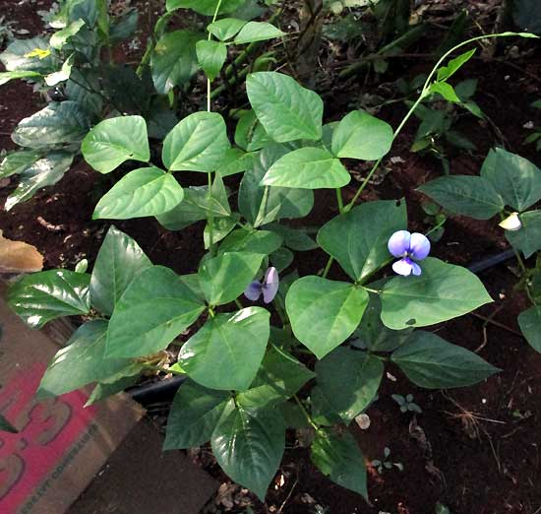

**Plate1.1: morphology of Cowpea**

A large morphological diversity is found within the crop, and the growth conditions and grower preferences for each variety vary from region to region. However, as the plant is primarily self-pollinating, its genetic diversity within varieties is relatively low(Egbadzor, *et al.,* 2014). Cowpeas can either be short and bushy (as short as 20 cm or 8 in) or act like a vine by climbing supports or trailing along the ground to a height of 2 m or 6 ft 7 inches (Sheahan, 2012). The taproot can penetrate to a depth of 2.4 m (7 ft 10 in) after eight weeks (Pottorff*et al.,*2012).

The size and shape of the leaves vary greatly, making this an important feature for classifying and distinguishing cowpea varieties. Another distinguishing feature of cowpeas is the long 20–50 cm (8–20 in) peduncles, which hold the flowers and seed pods. One peduncle can support four or more seed pods(Egbadzor*et al.,* 2014). Flower colour varies through different shades of purple, pink, yellow, and white and blue. Seeds and seed pods from wild cowpeas are very small, while cultivated varieties can have pods between 10 and 110 cm that is 4 - 43 inches long. A pod can contain six to 13 seeds that are usually kidney-shaped, although the seeds become more spherical the more restricted, they are within the pod. Their texture and colour are very diverse. They can have a smooth or rough coat and be speckled, mottled, or blotchy. Colours include white, cream, green, red, brown, and black, or various combinations.

**1.4.3 GROWTH HABIT**

Cowpea is predominantly a hot weather crop well adapted to semi-arid regionsand preferring temperatures between 20° and 35°C. It can be grown over a widerange of soil types and moisture regimes. The ecological zone most favourable toits production is the Sudan Savannah zone in the extreme northern parts of thecountry although the crop is also grown in the southern part of the country (Ejiga, 2009).Depending on the cultivar and the environment, cowpeas maytake from about 60 to 240 days to produce mature seeds. The crop is usuallyinterplanted with other crops such as yam, millet, sorghum, and maize by subsistence farmers without any chemical protection, while some farmers with largecowpea is harvested as pods from the plant by hand-picking onalternate days. (Ojomo and Raji, 2006) reported in their study on harvesting schedules,reported that with good pest control and planting in May/June, good qualityseeds are obtained if the crop is harvested when 75-80% of the pods are dry.

**1.4.4 ECONOMIC VALUE**

Several studies have shown that bean products can lower serum cholesterol levels. Daily consumption of 100-135 g of dry beans reduced serum cholesterol levels by ~20%, thereby reducing risk for coronary heart disease by40% as reported by (Anderson *et al.,* 2005).Legumes appear to have gained in popularity at a faster rate in the food service segment because they are easy to prepare, suitable for batch cooking ahead of time, reheatable, and can be portion controlled (Morrow, 2001). Indigenous African legume is economically, nutritionally, and environmentally the foremost crop that serves as a source of essential human dietary nutrients and as, a means of providing fodder for livestock. It also presents with other multi-functional traits, including the maintenance of the soil – ecology balance through nitrogen fixation in that it facilitates a symbiosis with nodulating bacteria (Ravelombola*et al.,* 2017).Cowpea is indeed a multi-faceted crop, providing revenue for millions of smallholder farmers, as well as for traders who sell the nutritious grain. By providing essential protein, minerals, and vitamins, it serves in most African countries, as a means of balancing the diet, thereby providing a cheaper means for accessing the necessary dietary nutrients and for positively influencing the well-being and health of the populace. In addition, all of its components are valuable as nutrients (Gonçalves*et al.,* 2016) – the leaves, pods, and seeds are nutritionally high in protein, with less fat, and are used extensively as the vegetable component in diets. In both the urban and rural settlements in most African countries, women generate income by trading in processed cowpea food and snacks. Cowpea is also important in livestock production, where the plant’s leaves and vines are dried and used as fodder/feed supplements in livestock husbandry. Cowpea is a key resource for a large number of people in the developing world, mainly in the arid/semi-arid tropical regions of the world (Muñoz-Amatriaín*et al.,* 2017). Cowpea dry grain contains 23–32% protein and essential amino acids (Carvalho*et al.,* 2017). Also, the green cowpea seeds, fresh and immature pods, and leaves contribute vegetable sources for human consumption (Gerrano*et al.,*2019). Its fresh leaves are used as vegetables, the haulms (cowpea pod walls, stems, and leaves) are used as livestock fodder, providing dietary nutrients for animals, and as income for the farmers (Kebede and Bekeko, 2020). Cowpea is highly prized as a source of food, for fodder in livestock feeds, and an important but cheaper means of improving and boosting soil fertility through biological nitrogen fixation. As important as it is in human nutrition, cowpea is equally useful in providing the necessary energy and protein in livestock production. More so, owing to its adaptation to different climatic conditions and its ability to grow in a less-fertile soil environment, it is highly appreciated as forage and a potential fodder crop for the future (Alemu*et al.,* 2016). It is a key leguminous crop in the arid and tropical regions of Africa, Asia, and Latin America (Xiong*et al.,* 2016). Cowpea is relished as a source of nutritious food and a variety of snacks that provide humans with cheaper proteins, thereby enhancing food security (Agbogidi and Egho, 2012). It is a vital source of beneficial micronutrients, proteins, amino acids, antioxidants, vitamins, and minerals, with immense therapeutic and nutritional security benefits. It is often used in mixed cropping systems to offer the multi-functional benefits of a nutritious grain, as a fodder crop, and as a means to improve soil fertility (Belay *et al.,* 2017). Importantly, it is useful in agro-ecological conservation. It is used mainly as an inter-crop with other food crops to boost soil fertility and add nutrients to degraded soil through its nitrogen-fixing property (Rego*et al.,* 2015). It is postulated that cowpea can fix about 337kgN. ha-1 (Yahaya, 2019). The average nitrogen addition/contribution to the soil during the cowpea growth and development phase is in the range of 40–80kgN. ha-1 and sometimes up to 200kgN. ha-1 (Meena*et al.,* 2015). Also, it is useful as a cover crop or an erosion-preventing crop; it helps in suppressing weeds; and also aids in the retention of moisture (Das*,* 2018). Another key advantage of cowpea production is that when used as an inter-crop with other crops, it induces the growth of beneficial soil microorganisms and reduces the use of synthetic agrochemicals (Sun *et al.,* 2019). In terms of importance, cowpea production contributes significantly to economic productivity and environmental sustainability in Africa (Ayala *et al.,* 2020).

**1.4.5 PEST AND DISEASES**

A major constraint in limiting cowpea yields can be attributed to bacterial pathogens, which lead to massive crop losses of upward of 70% in the form of seed grain, pod, and fodder reduction (Agbicodo*et al.,* 2010). Some of these destructive pathogens are transmitted via the seed (De Lima-Primo *et al.,* 2015), while some are transmitted via the soil-borne route (Constantin *et al.,* 2016). Among the most destructive bacterial pathogens of cowpea are members of the Xanthomonas genus (Durojaye*et al.,* 2019).Nematodes are responsible for huge losses in cowpea production and are also one of the constraints limiting improvements in cowpea production (Dareus*et al.,* 2021). This they accomplish by impeding the uptake of water and nutrients. Also, nematodes limit cowpea growth and development by interfering in the pathways towards cell differentiation and in the transportation of auxin (Gheysen and Mitchum, 2011). Meloidogynejavanica and Meloidogyne incognita are the two major nematodes destroying cowpea (Oliveira *et al.,* 2012).

Fungal pathogens are the topmost destructive agents/phytopathogens of planted crops globally (Fisher *et al.,* 2012). Very many species of different genera of fungi destroy cowpea in the field and during the post-harvest stage. Furthermore, seed and soil-borne fungal pathogens have been implicated in the loss of cowpea production that sometimes rises to 100% (Mbeyagala*et al.,* 2014). Notable fungal pathogens of cowpea include *Rhizoctoniasolani, Colletotrichum spp., Fusariumoxysporum, Macrophominaphaseolina,* and*Sclerotiumrolfsii* (Pottorff*et al.,* 2014).Viral pathogens can adversely impact cowpea productivity; some of these have been linked in some cases to cowpea losses of up to 100%. Their destructive mechanisms that negatively affect cowpea include the reduction they cause in the population/growth and development of Rhizobium, thereby reducing the necessary root nodulation in cowpea (Taiwo*et al.,* 2014). Up to 40 viruses adversely affect cowpea yields globally. Some of the most devastating viral pathogens of cowpea are the cowpea aphid-borne mosaic virus (CABMV), cowpea wild mottle virus (CPMMV), and CPSMV (Odedara and Kumar, 2017). Parasitic weeds also cause serious losses in cowpea production/yields (Li and Timko, 2009).

**CHAPTER 2**

**MATERIALS AND METHODS**

**2.1 AREA OF STUDY**

The laboratory activities for the cooking time of the cowpea were conducted at the Regional Centre for Biotechnology and Bioresources Research (RCBBR) of the University of Port Harcourt, in Choba Rivers State, Nigeria.

**2.2 SOURCE OF EXPERIMENTAL MATERIALS**

The cowpea samples used in the study were obtained from the Institute for Agricultural Research (IAR), Samuru in the Northern Region of Nigeria. The various varieties of cowpea were coded with the prefix TVU, IAR, SAMPEA, ITUD, UAM, and IT, while the control sample with prefix OT used for this experiment was purchased in the local market at Rumuokoro in Obio/Akpor Local Government Area, Rivers State, Nigeria.

**2.1. Cowpea collection codes, sample names, collection location and accession type.**

|  |  |
| --- | --- |
| S/N Sample code | Accession name Location Accession type |
| 1. CP- 01 | 355 TVU- 16518 IAR, Samaru, Zaria Seed |
| 1. CP- 02 | 255 TVU- 12353 IAR, Samaru, Zaria Seed |
| 1. CP- 03 | 386TVU- 4406 IAR, Samaru, Zaria Seed |
| 1. CP- 04 | 2 TVU- 301 IAR, Samaru, Zaria Seed |
| 1. CP- 05 | 143TVU- 16343 IAR, Samaru, Zaria Seed |
| 1. CP- 06 | 151 TVU- 675 IAR, Samaru, Zaria Seed |
| 1. CP- 07 | 5 TVU- 301 IAR, Samaru, Zaria Seed |
| 1. CP- 08 | 127 TVU- 14090 IAR, Samaru, Zaria Seed |
| 1. CP- 09 | 53 TVU- 8266 IAR, Samaru, Zaria Seed |
| 1. CP- 1 0 | 257 TVU- 23510 IAR, Samaru, Zaria Seed |
| 1. CP- 11 | 156 lAR-016-059 IAR, Samaru, Zaria Seed |
| 1. CP- 1 2 | 242 TVU- 384 IAR, Samaru, Zaria Seed |
| 1. CP- 13 | 277 TVU- 4708 IAR, Samaru, Zaria Seed |
| 1. CP- 14 | SANZI 351 IAR, Samaru, Zaria Seed |
| 1. CP- 15 | 358 TVU- 14500 IAR, Samaru, Zaria Seed |
| 1. CP- 16 | 329 TVU- 16346 IAR, Samaru, Zaria Seed |
| 1. CP- 17 | 138 TVU- 456 IAR, Samaru, Zaria Seed |
| 1. CP- 18 | 136 lAR-016-052 IAR, Samaru, Zaria Seed |
| 1. CP- 19 | 155 TVU- 14626 IAR, Samaru, Zaria Seed |
| 1. CP- 20 | 4 TVU- 15088 IAR, Samaru, Zaria Seed |
| 1. CP- 21 | TVU- 109313 IAR, Samaru, Zaria Seed |
| 1. CP- 22 | 6 TVU- 158814 IAR, Samaru, Zaria Seed |
| 1. CP- 23 | 388 TVU- 16480 IAR, Samaru, Zaria Seed |
| 1. CP- 24 | 102 TVU- 116 IAR, Samaru, Zaria Seed |
| 1. CP- 25 | 87 TVU- 848 IAR, Samaru, Zaria Seed |
| 1. CP- 26 | 123 TVU- 849 IAR, Samaru, Zaria Seed |
| 1. CP- 27 | 145 TVU- 4632 IAR, Samaru, Zaria Seed |
| 1. CP- 28 | 192 TVU- 15892 IAR, Samaru, Zaria Seed |
| 1. CP- 29 | 36 lAR-016-047 IAR, Samaru, Zaria Seed |
| 1. CP-30 | 168 lAR-016-046 IAR, Samaru, Zaria Seed |

**2.3 METHODS**

**2.3.1 COOKING METHODOLOGY**

**2.3.2 SOAKING:**

Four seeds of each accession were weighed using a weighing balance and transferred in labelled disposable cup. 60ml of distilled water was added to each of the disposable cup and soaked at room temperature (25- 30oc) overnight for 16hours.

The water was drained from the top of the disposable cup and the water was kept in a separate beaker. The weight after soaking was recorded.

The increase in weight as the amount of water absorbed was calculated, the drained water was returned to its respective cup.

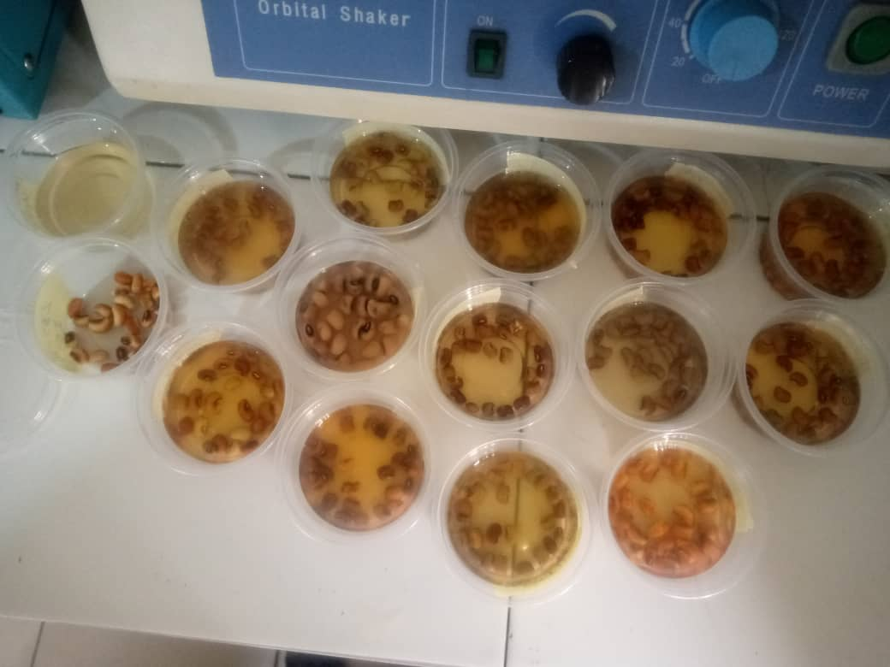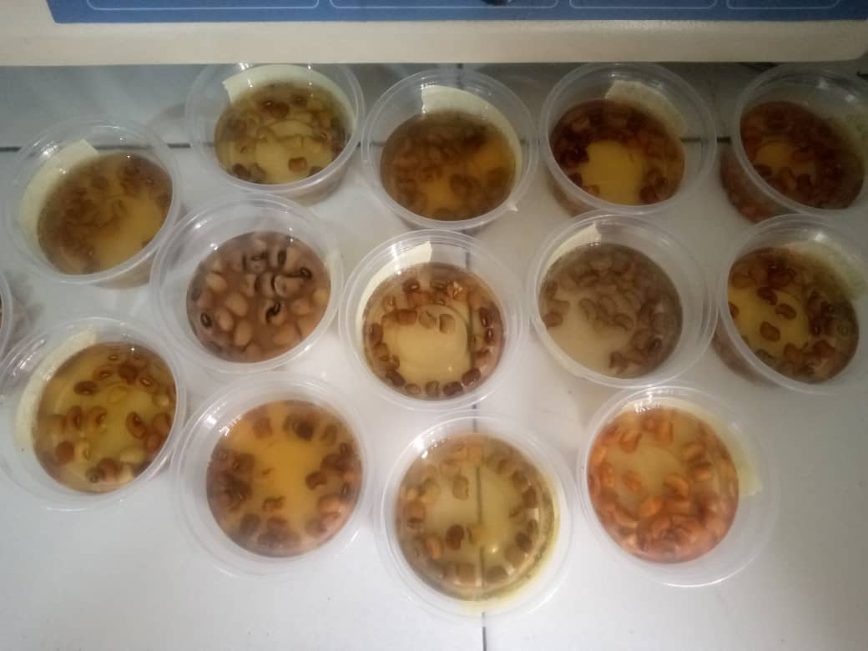

Plate 2.1: soaked Cowpea Samples

**2.2.3 COOKING EVALUATION**

1. Four seeds each of the 30 samples of *Vignaunguiculata* were selected from the soaked samples.

2. The seeds were then placed in a stainless-steel container and sealed with Aluminium foil paper and cooked using an electronic hot plate.

3. The grains of the cowpea cooking time were determined by using the sensory and tactile method by Yueng, (2007) using trained evaluators.

4. The measured parameters are aroma of seed and broth, tactile texture cooking doorness, broth opacity, seed coat splitting, and cotyledon splitting. Also, to take measurement for the solid loss of a brix refractoeter (AT Ago pocket PAL-1) was used.

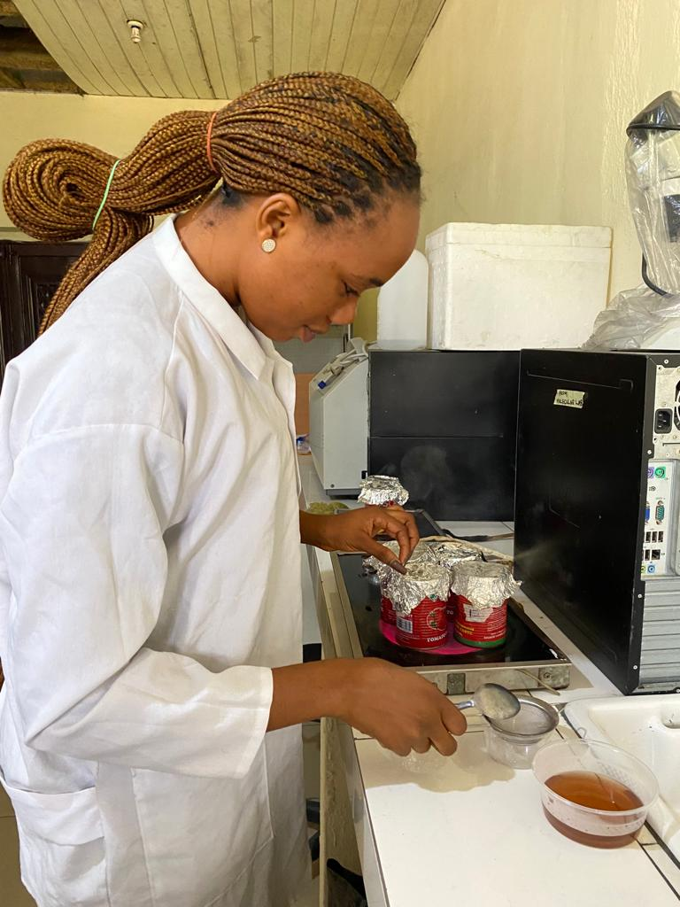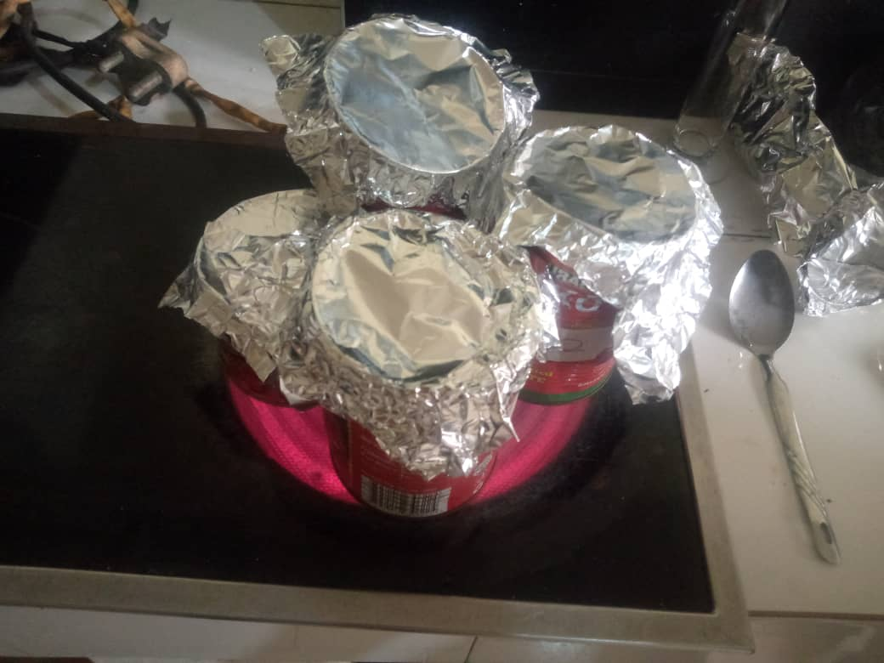

Plate 2.1: cooking process.

The following parameters were rated;

**To measure Aroma of seed and broth**:

Take on sniff and rate; 1=nearly none, 2=faint, 3= apparent, 4= more apparent, 5= pungent.

**To measure Tactile texture:** Press at least three seeds, one at a time, between the thumb and the four fingers and rate: 1 =seed is difficult or not able to smash and cotyledon feels hard, 2= seed is less difficult to smash and cotyledon feels slightly hard, 3= seed is firm but smashes easily and cotyledon feels soft, 4= there is little resistance to smash seed and cotyledon feels mushy, 5= seed is easily pressed into a mush.

**To measure cooked doneness:** Rate use five-point scale: 1= under cooked, 2= slightly under cooked, 3= cooked, 4= slightly over cooked, 5= over cooked.

**To measure broth opacity:** Place bowls on white paper with black text and rate;

1= text legible and clear, 2=text legible but blurry, 3= text very blurry and or may not be legible, 4= cannot see text, but able to see silhouette of any object when the bowl is lifted off paper, 5= completely opaque.

To evaluate seed coat and the cotyledon splitting: count the number of torn seed coats and cracked cotyledon.

**NOTE**: to produce an accurate sensory evaluation, the evaluator must avoid smoking, chewing of gum or eating 1 hour prior to and during evaluation.

After cooking, estimate the final broth weight in grams using the following formula:

**Final Broth WT = 60g –(Final seed WT- Initial seed WT)**

**CHAPTER THREE**

**RESULTS**

**3.2 GENETIC DIVERSITY OF THE COWPEA SEEDS**

**3.2.1 Cluster analysis**

The result of the cluster analysis based on the cooking time and textual characteristics of the 30 cowpea seeds used in this study is presented in Fig. 3.1. From the result, it was observed that the cowpea seeds are grouped into 2 major clusters A and B. It was observed that only accession 106 grouped in cluster A, indicating that it is distinctively different other accessions in clusters B. In cluster B it was observed that there were two sub-clusters I and II. In sub-cluster II, it was observed that three accessions 102, 109, 118 grouped together. This indicates that they share the same cooking time and textual characteristics.

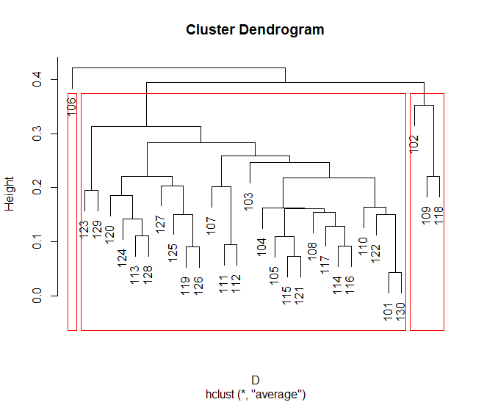

I

II

B

A

Figure 3.1: Cluster analysis based on the cooking time and textual characteristics of the 30 cowpea seeds used in this study

The result of the heat-map based on the cooking time and textual characteristics of the 30 cowpea seeds used in this study is presented in Figure3.1. The result showed the relationship between some cowpea lines representing the composite groups in the cluster analysis. F

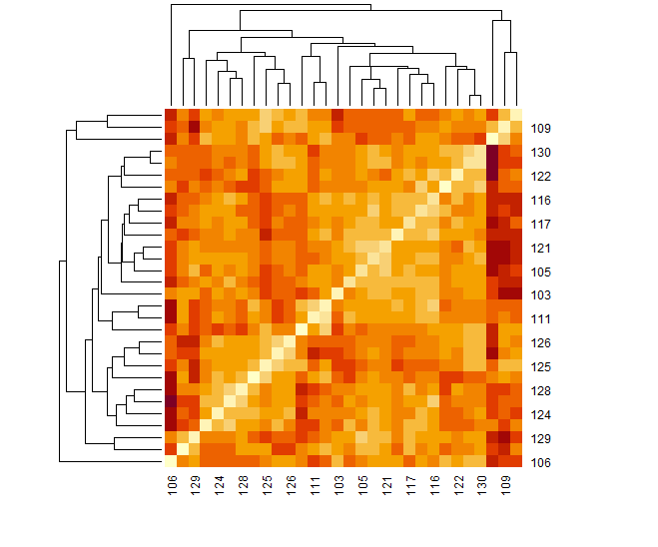

Fig. 3.2: Heat-map based on the cooking time and textual characteristics of the 30 cowpea seeds used in this study

**3.2.2 Correlation of the cooking and textural characteristics**

The result of the correlation analysis for the various cooking time parameters is presented in the correlation matrix in Table 3.4. From the result, it was observed that the correlation of trait4 and trait3is 0.48, which indicate that they are weakly positively correlated, while trait8 and trait3 was -0.41 means that they are weakly negatively correlated.

Table 3.1: The textural characteristics of the 30 cowpea seeds used in this study

Accessions trait1 trait2 trait3 trait4 trait5 trait6 trait7 trait8 trait9 trait10 trait11 trait12

Accessions 1.00 -0.01 NA -0.34 -0.27 -0.31 -0.21 0.05 -0.40 -0.02 0.32 -0.20 0.37

trait1 -0.01 1.00 NA 0.28 0.68 0.02 -0.01 0.07 -0.30 0.05 -0.26 0.01 0.20

trait2 NA NA 1 NA NANANANANANANANANA

trait3 -0.34 0.28 NA 1.00 0.48 0.09 0.11 0.10 -0.06 0.02 -0.15 0.24 -0.13

trait4 -0.27 0.68 NA 0.48 1.00 0.08 -0.13 0.15 -0.25 -0.17 -0.21 0.08 -0.21

trait5 -0.31 0.02 NA 0.09 0.08 1.00 0.06 -0.41 0.22 -0.07 0.35 0.32 -0.30

trait6 -0.21 -0.01 NA 0.11 -0.13 0.06 1.00 0.05 -0.02 0.26 -0.06 0.09 -0.14

trait7 0.05 0.07 NA 0.10 0.15 -0.41 0.05 1.00 -0.28 0.11 -0.26 -0.13 0.03

trait8 -0.40 -0.30 NA -0.06 -0.25 0.22 -0.02 -0.28 1.00 -0.02 -0.11 0.07 -0.23

trait9 -0.02 0.05 NA 0.02 -0.17 -0.07 0.26 0.11 -0.02 1.00 -0.14 0.08 -0.07

trait10 0.32 -0.26 NA -0.15 -0.21 0.35 -0.06 -0.26 -0.11 -0.14 1.00 -0.02 -0.18

trait11 -0.20 0.01 NA 0.24 0.08 0.32 0.09 -0.13 0.07 0.08 -0.02 1.00 -0.20

trait12 0.37 0.20 NA -0.13 -0.21 -0.30 -0.14 0.03 -0.23 -0.07 -0.18 -

**3.1 COOKING EVALUATION**

Figure 3.1: Chart showing the cooking time of various accessions.

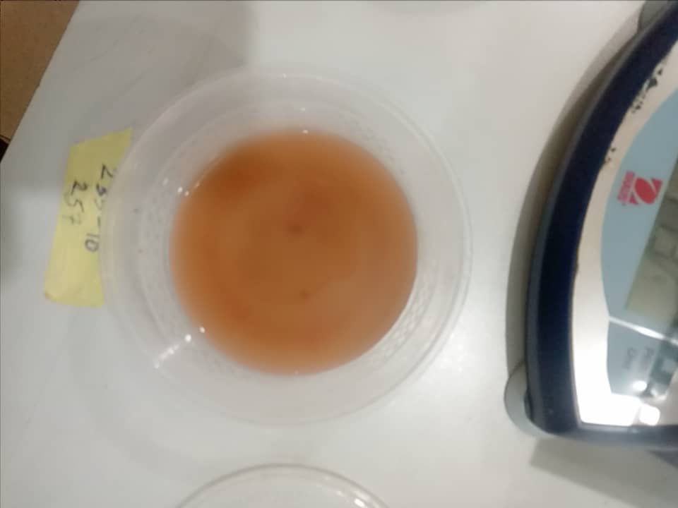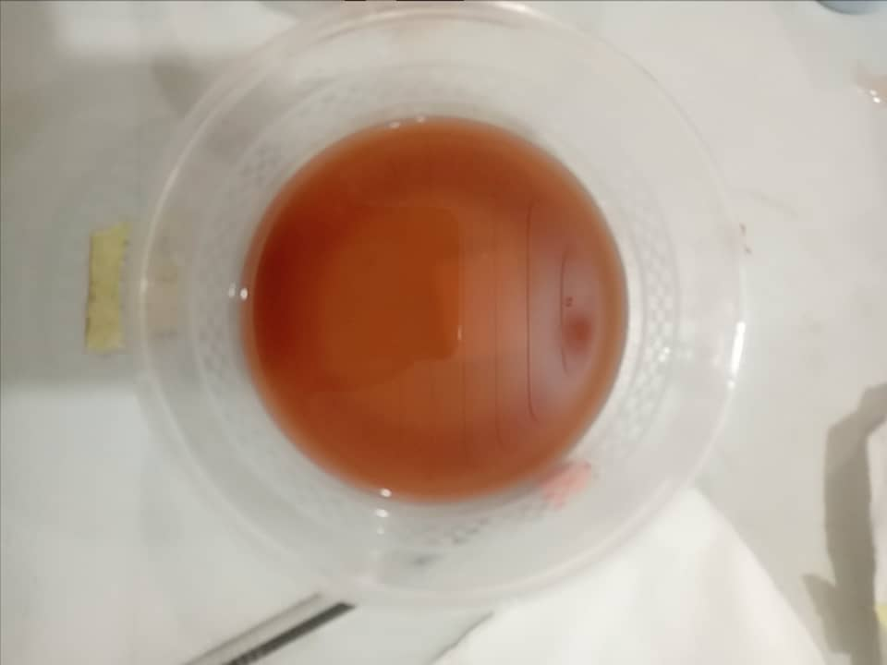

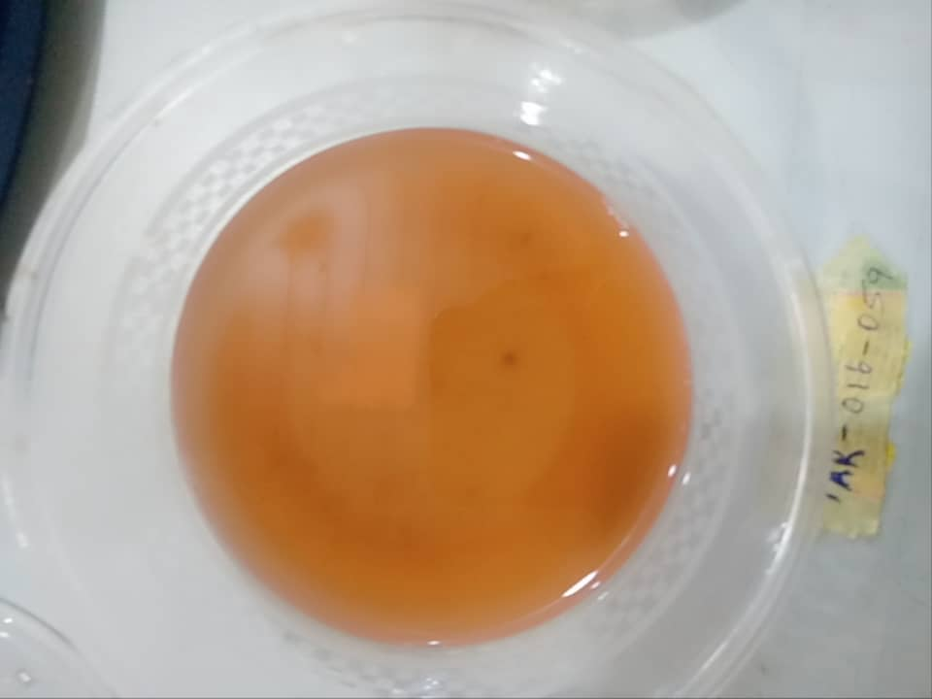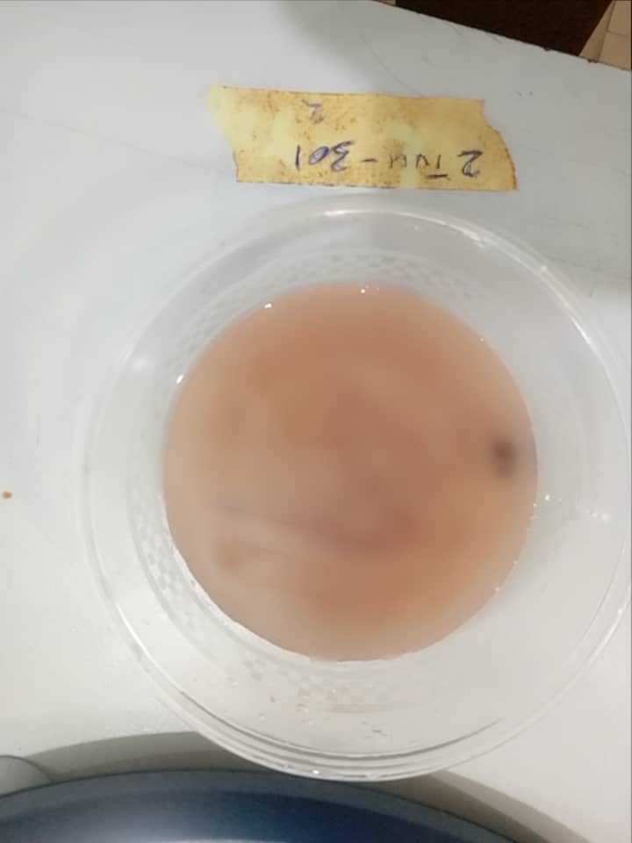

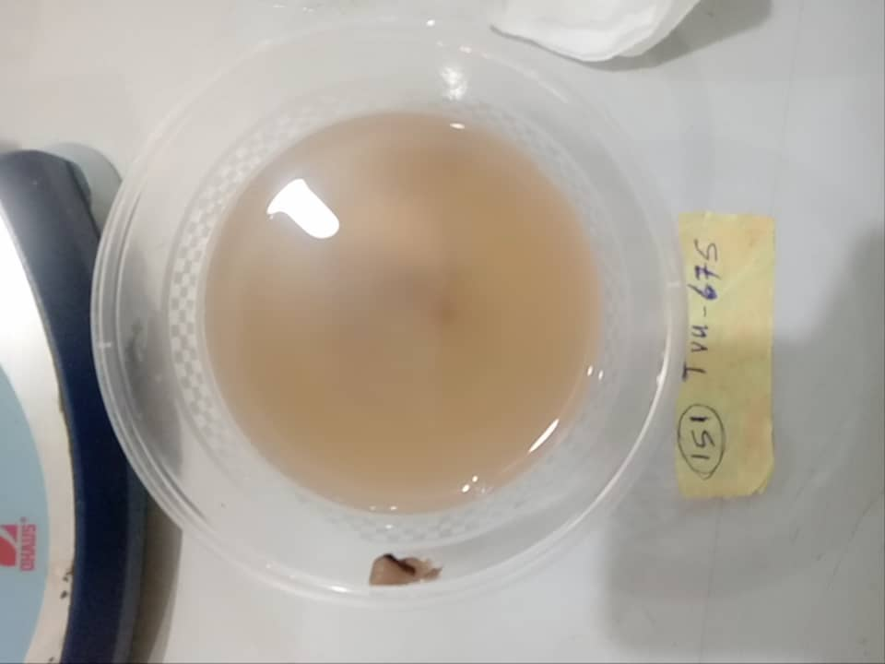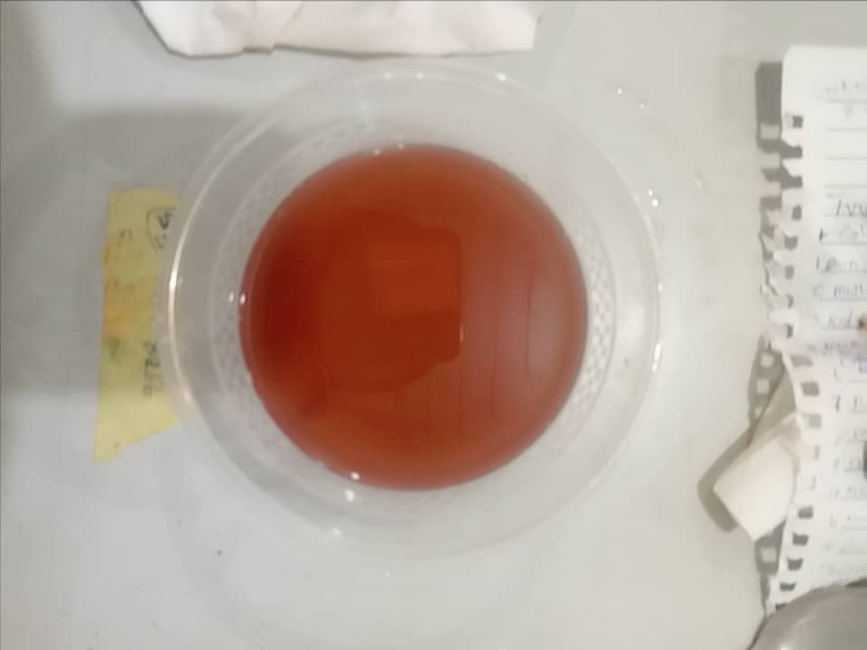

Plate 3.1: Showing the broth water



Plate 3.2: Checking for the Broth opacity using the Refractor (ATAgo pocket PAL -1)

**CHAPTER FOUR**

**DISCUSSION AND CONCLUSION**

**4.1 DISCUSSION**

Recent research revealed that most of the TVUs (cultivated) accessions cooked for 50 minutes while iron white, akara bean, iron brown and honey bean (market-class) cooked for 51 minutes. Sometimes to soften the cowpea grains while it’s been cooked to reduce cooking time to 20-25 minutes (Ukomadu *et al.*, 2023). The accessions 255 TVU- 12353, 136 lAR-016-052 and 36 lAR-016-047 have the shortest time for cooking at 120 minutes.

The result of the cluster analysis based on the cooking time and textual characteristics of the 30 cowpea seeds used in this study is presented in Fig. 3.1. Show that the cowpea seeds are grouped into 2 major clusters A and B. It was observed that only accession 106 grouped in cluster A, indicating that it is distinctively different other accessions in clusters B.It was observed that only accession 106 grouped in cluster A, indicating that it is distinctively different other accessions in clusters B. In cluster B it was observed that there were two sub-clusters I and II. In sub-cluster II, it was observed that three accessions 102, 109, 118 grouped together. This indicates that they share the same cooking time and textual characteristics. They are weakly negatively correlated

The result of the heatmap based on the cooking time for the 30 (seed coat colour) cowpea seeds showed the relationship between some cowpea lines representing the composite groups in the cluster analysis.

**4.2 CONCLUSION**

The study has established new information’s about the cooking time of the 30 accessions and has determined the accession with the best cooking time so as to increase the utility ofthe crop and reduce the loss of energy and time while preparing the crop plant.

**4.3 RECOMMENDATION**

Research should be conducted for the extraction of the gene responsible for the fast cooking time, to enhance the production of a new cultivar.

**REFRENCES**

Agbicodo, E., Fatokun, C., Bandyopadhyay, R., Wydra, K., Diop, N., and Muchero, W. (2010). Identification of Markers Associated with Bacterial Blight Resistance Loci in Cowpea [*Vignaunguiculata* (L.) Walp.]. *Euphytica,* 175: 215–226.

Agbogidi, O. M., and Egho, E. (2012). Evaluation of Eight Varieties of Cowpea (*Vignaunguiculata* (L.) Walp) in Asaba Agro-ecological Environment, Delta state, Nigeria. *European Journal of Sustainable Development*, 1:303-309.

Alemu, M., Asfaw, Z., Woldu, Z., Fenta, B. A. and Medvecky, B. (2016). Cowpea (*Vignaunguiculata* (L.) Walp.) (Fabaceae) Landrace Diversity in Northern Ethiopia. International Journal of Biodiversty and Conservation, 8: 297–309.

Anderson, J. W. (2005). Cholesterol-lowering Effects of Canned Beans for Hyper-cholestrolmic. Medical and Clinical Research, 33(4):871.

Belay, F., Gebreslasie, A., and Meresa, H. (2017). Agronomic performance evaluation of cowpea [Vignaunguiculata (L.) Walp] varieties in Abergelle District, northern Ethiopia. J. Plant Breed. Crop Science, 9:139–143.

Boukar, O., Belko, N., Chamarthi, S., Togola, A., Batieno, and J., Owusu, E., (2019). Cowpea (*Vignaunguiculata*): Genetics, Genomics and Breeding*, Plant Breed*. 138, 415–424.

Boukar, O., Bhattacharjee, R., Fatokun, C., Kumar, P. L., and Gueye, B. (2013). “Chapter 6: Cowpea,” in Genetic and Genomic Resources of Grain Legume Improvement. eds. M. Singh, H. D. Upadhyaya, and I. S. Bisht (Oxford: Elsevier), 137–156.

Boukar, O., Fatokun, C. A., Huynh, B.-L., Roberts, P. A., and Close, T. J. (2016). Genomic Tools in Cowpea Breeding Programs: Status and Perspectives. *Frontiers in Plant Science*, 7:757-763.

Carvalho, M., Lino-Neto, T., Rosa, E., and Carnide, V. (2017). Cowpea: A Legume Crop for a Challenging Environment. Journal of Science. *Food and Agriculture*, 97: 4273–4284.

Constantin, E., Cleenwerck, I., Maes, M., Baeyen, S., Van Malderghem, C., and De Vos, P. (2016). Genetic Characterization of Strains Named as *Xanthomonasaxonopodis*pv. Dieffenbachiae leads to a taxonomic revision of the X. axonopodis species complex. *Plant Pathology*, 65: 792–806.

Dareus, R., Porto, A. C. M., Bogale, M., Digennaro, P., Chase, C. A. and Rios, E. F. (2021). Resistance to *Meloidogyneenterolobii* and *Meloidogyne incognita* in Cultivated and Wild Cowpea. *Horticultural Science,* 56: 460–468.

De Lima-Primo, H. E., Nechet, K. D. L., Halfeld-Vieira, B. D. A., De Oliveira, J. R., Mizubuti, E. S., and De Souza, G. R. (2015). Epidemiological Aspects of Cowpea Bacterial Blight. *Tropical Plant Pathology*. 40, 46–55

Dolvo, F. E., Williams, E. C. and Zoaka, L. (2006) "Cowpeas: Home Preparation and Use in W. Africa" International Development Research Centre, Ottawa, 2.

Durojaye, H. A., Moukoumbi, Y. D., Dania, V. O., Boukar, O., Bandyopadhyay, R., and Ortega-Beltran, A. (2019). Evaluation of Cowpea (*Vignaunguiculata* (L.) Walp.) Landraces to Bacterial Blight caused by *Xanthomonasaxonopodis*pv. Vignicola. Crop Protection, 116: 77–81.

Egbadzor, K. F., Kwadwo. O., Martin, Y., Lawrence, M. A., Opoku-Agyeman, M. O; Danquah, E. Y. and Offer, S. K. (2014). "Diversity in 113 cowpea (*Vignaunguiculata*(L) Walp) Accessions Assessed with 458 SNP markers". S*pringerPlus*. 3: 541-546.

Ejiga, N. O.(2009). The efficiency of the indigenous food grain marketing systems in Nigeria, Savannah, Dec, 8(2):70-83.

Fashakin, J. B. and Ojo, F. A () Chemical composition and nutritive changes of some improved varieties of cowpea (Vignaunguiculata). (L. Walp)2: New breeds of varieties from the International Institute of Tropical Agriculture, Ibadan, Nigeria, Tropical Sci., 28, 191-199

Fisher, M. C., Henk, D. A., Briggs, C. J., Brownstein, J. S., Madoff, L. C., and Mccraw, S. L., (2012). Emerging fungal threats to animal, plant and ecosystem health. *Nature*, 484: 186–194.

Gerrano, A. S., Jansen Van Rensburg, W. S., Venter, S. L., Shargie, N. G., Amelework, B. A. and Shimelis, H. A. (2019). Selection of Cowpea Genotypes Based on Grain Mineral and Total Protein Content. Soil Plant Science, 69: 155–166.

Gheysen, G., and Mitchum, M. G. (2011). How Nematodes Manipulate Plant Development Pathways for Infection. Plant Biology, 14: 415–421.

Gonçalves, A., Goufo, P., Barros, A., Domínguez-Perles, R., Trindade, H., and Rosa, E. A. (2016). Cowpea (*Vignaunguiculata* L. Walp), a Renewed Multipurpose Crop for a more Sustainable Agri-food System: Nutritional Advantages and Constraints. Journal Science, Food and Agriculture, 96: 2941–2951.

Irondi, E. A., Ogunsanmi, A. O., Ahmad, R. S., Ajani, E. O., Adegoke, B. M., and Boligon, A. A. (2019). Effect of Roasting on Phenolics Composition, Enzymes Inhibitory and Antioxidant Properties of Cowpea pulses. Journal of Food Meas. Charact. 13, 1489–1496

Johnston, A. K, and P. P. Dorrihan, P. P(2003).Losses of pectic substances during cooking andthe effect of water hardness, *Journal of Science, Food and Agriculture*, 34: 733-736.

Kamara, A. Y., Ekeleme, F., Jibrin, J. M., Tarawali, G., and Tofa, I. (2014). Assessment of Level, Extent and Factors Influencing Striga Infestation of Cereals and Cowpea in a Sudan Savanna Ecology of Northern Nigeria. Agriculture, Ecosystem and Environvironmet, 188: 111–121.

Kebede, E., and Bekeko, Z. (2020). Expounding the production and importance of cowpea (Vignaunguiculata (L.) Walp.) in Ethiopia. *Cogent Food Agriculture*, 6:1769-805.

Kumar, S., Thombare, P., and Kale, P. (2019). Climate smart agriculture: challenges, implications, innovations for achieving food and nutrition security. Agric. Food Newsl. 1, 267–271.

Li, J., and Timko, M. P. (2009). Gene-for-gene resistance in Striga-cowpea associations. *Science*, 325:1094.

Lonardi, S., Muñoz-Amatriaín, M., Liang, Q., Shu, S., Wanamaker, S. I. and Lo, S., (2019). The genome of cowpea (Vignaunguiculata [L.] Walp.). Plant J. 98, 767–782.

Mbeyagala, E. K., Mukasa, B. S., Tukamuhabwa, P., and Bisikwa, J. (2014). Evaluation of cowpea genotypes for virus resistance under natural conditions in Uganda. Journal of Agricultural Science, 6:176-183.

Muñoz-Amatriaín, M., Mirebrahim, H., Xu, P., Wanamaker, S. I., Luo, M., Alhakami, H., et al. (2017). Genome Resources for Climate-resilient Cowpea, an Essential Crop for Food Security. *Plant Journal*. 89:1042–1054.

Odedara, O. O., and Kumar, P. L. (2017). Incidence and diversity of viruses in cowpeas and weeds in the unmanaged farming systems of savanna zones in Nigeria. Plant *Protection*, 50: 1–12.

Ojomo O. A. and J. A. Raji. (2006). A harvesting schedule proposed for early season cowpea in Southern Nigeria. *Tropical Grain Legume Bulletin*, 3: 3-5.

Oliveira, J., Andrade, N., Martins-Miranda, A., Soares, A., Gondim, D., Araújo-Filho, J., et al. (2012). Differential expression of antioxidant enzymes and PR-proteins in compatible and incompatible interactions of cowpea (Vignaunguiculata) and the root-knot nematode *Meloidogyne incognita*. *Plant Physiology and Biochemistry*, 5: 145–152.

Onigbinde A. O. and Akinyele, I. O. (2003). Oligosaccharide Content of 20 Varieties of Cowpeas in Nigeria, *Journal of Food Science*, 48(6):1250-1251.

Pottorff, M. O., Li, G., Ehlers, J. D., Close, T. J., and Roberts, P. A. (2014). Genetic Mapping, Synteny, and Physical Location of Two Loci for *Fusariumoxysporum* f. sp. tracheiphilum Race 4 Resistance in Cowpea [Vignaunguiculata (L.) Walp]. Molecular Breeding, 33: 779–791.

Ravelombola, W., Qin, J., Shi, A., Weng, Y., Bhattarai, G. and Dong, L. (2017). A SNP-based association analysis for plant growth habit in worldwide cowpea (*Vignaunguiculata* (L.) Walp) Germplasm. *Euphytica*, 213:284.

Rego, A., Diop, I., Sadio, O., Sylva, M., Agbangba, C. E., Touré, O., et al. (2015). Response of cowpea to symbiotic micro-organisms inoculation (arbuscularmycorrhizal fungi and rhizobium) in cultivated soils in Senegal. Universal Jouranl of Plant Science, 3:32–42.

Sheahan, C. M. (2012). "Plant guide for cowpea (Vignaunguiculata)". USDA-Natural Resources Conservation Service, Cape May Plant Materials Center, Cape May, New Jersey, 222: 34-37.

Shi, A., Buckley, B., Mou, B., Motes, D., Morris, J. B., Ma, J., et al. (2016). Association Analysis of Cowpea Bacterial Blight Resistance in USDA Cowpea Germplasm. *Euphytica*, 208: 143–155.

Singh, B. (2014). Cowpea: The Food Legume of the 21st Century. Crop Science Society of America. USA: Wiley, 192.

Sun, F., Pan, K., Olatunji, O. A., Li, Z., Chen, W., Zhang, A., et al. (2019). Specific Legumes Allay Drought Effects on Soil Microbial Food Web Activities of the Focal Species in Agroecosystem. *Plant Soil*, 437: 455–471.

Taiwo, L., Taiwo, M., Shoyinka, S., Jegede, S., Okogun, J., and Oyatokun, O. (2014). Interactive Effects of Virus and Rhizobium Inocula on Nodulation, Growth and Yield of Cowpea. International Journal Plant Physiology Biochemistry, 6: 34–39.

Ukomadu, J., Odogwu, B. A. and Agbagwa, I. O. (2022). Phenotypic Diversity of Cowpea (Vignaunguiculata L. Walp) Based on Shorter Cooking Time and Canning Quality Traits. *Indian Journal Pure Applied Bioscience*, 10(6): 1-16.

Xiong, H., Shi, A., Mou, B., Qin, J., Motes, D., and Lu, W. (2016). Genetic Diversity and Population Structure of Cowpea (*Vignaunguiculata* L. Walp). *PLoS One* 11: e0160941.

Yahaya, D. (2019). Evaluation of Cowpea (Vignaunguiculata (L.) Walp) Genotypes for Drought Tolerance. dissertation/master’s thesis. Tennessee State University.